Finger Tapping Study
In this task you will be asked to press buttons with your right hand.
On the computer screen you will see a picture of a hand with a circle above each finger like this:
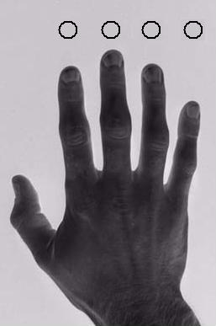
When one of the circles turns black, press the same finger as quickly as you can. For example, when the circle above the ring finger goes black press your ring finger:
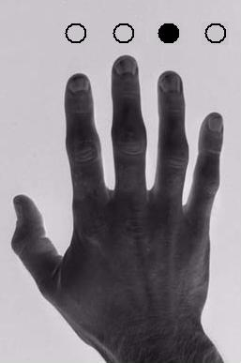
Sometimes all the circles will turn black at the same time. When this happens choose any finger to press. Don’t press all your fingers at the same time – just choose one. When choosing make a fresh choice each time – you can choose any one of the four options in each trial.
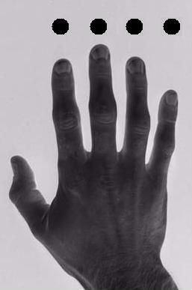

Thanks!

